i-Finance UAT Results — Task Management (App 207)
Automated UAT run · Round 2 · 13-Jun-2026 · Environment: http://localhost:8092 (dev-proxy → ADB PROD)
Executed by Claude (Playwright + ORDS). Scope: the UI/UX rework onto the shared platform design plus the functional enhancements — team edit, member management, task assignment with reassignment tracking, milestones, meetings and documents. Personas: SYS_ADMIN (ADMIN) and a non-admin (SHAIKHA.GALAMERI). Test data created during the run is prefixed "UAT".

Summary
27 cases — PASS: 27
Area | Cases | Pass | Fail/Other | Pass %
Access & Session | 3 | 3 | 0 | 100%
Dashboard | 2 | 2 | 0 | 100%
Teams | 3 | 3 | 0 | 100%
Team Detail | 2 | 2 | 0 | 100%
Members | 3 | 3 | 0 | 100%
Tasks | 5 | 5 | 0 | 100%
Artifacts | 5 | 5 | 0 | 100%
Cross-cutting | 4 | 4 | 0 | 100%

Access & Session

TM-ACC-01 — Entry from Admin via switcher
PASS · Shared session · 12s
Expected: TM (App 207) opens logged-in with no second login; TM brand cube; role-appropriate nav
Result: Admin login → module switcher → TM (App 207) opened logged-in, no second login
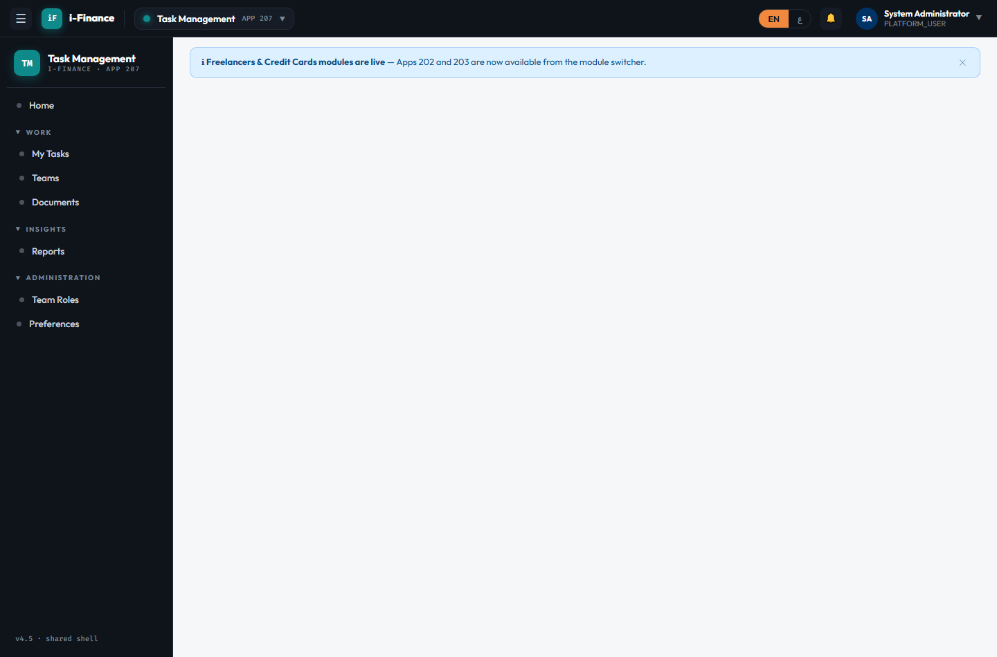
Evidence: TM-ACC-01.png

TM-ACC-02 — Direct open without login
PASS · No session · 9s
Expected: Redirected to the Admin portal login; no TM content before login
Result: TM opened without a session redirected to the Admin portal login
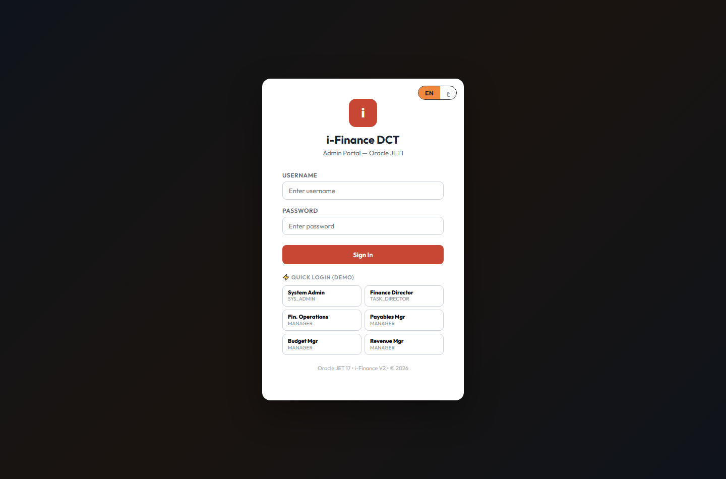
Evidence: TM-ACC-02.png

TM-ACC-03 — Admin-only nav hidden for non-admin
PASS · Role gating · 6s
Expected: Team Roles (admin) nav hidden for non-admins; Teams/My Tasks available
Result: Non-admin (SHAIKHA.GALAMERI) enters TM via shared session; Team Roles admin nav hidden
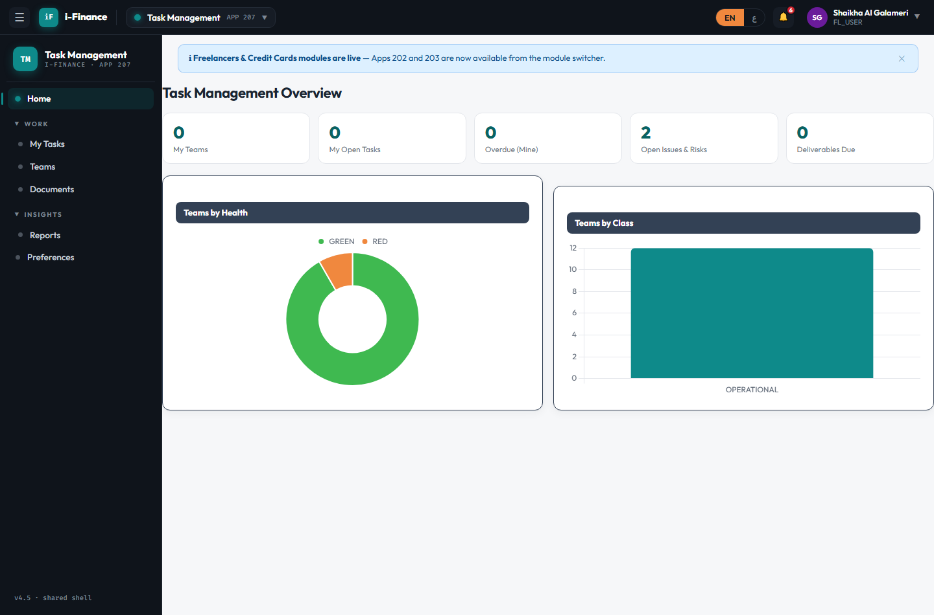
Evidence: TM-ACC-03.png

Dashboard

TM-DSH-01 — Five live KPI tiles
PASS · KPI tiles · 3s
Expected: My Teams / My Open Tasks / Overdue / Open Issues & Risks / Deliverables Due tiles show live numbers
Result: 5 KPI tiles render: 12, 0, 0, 2, 0
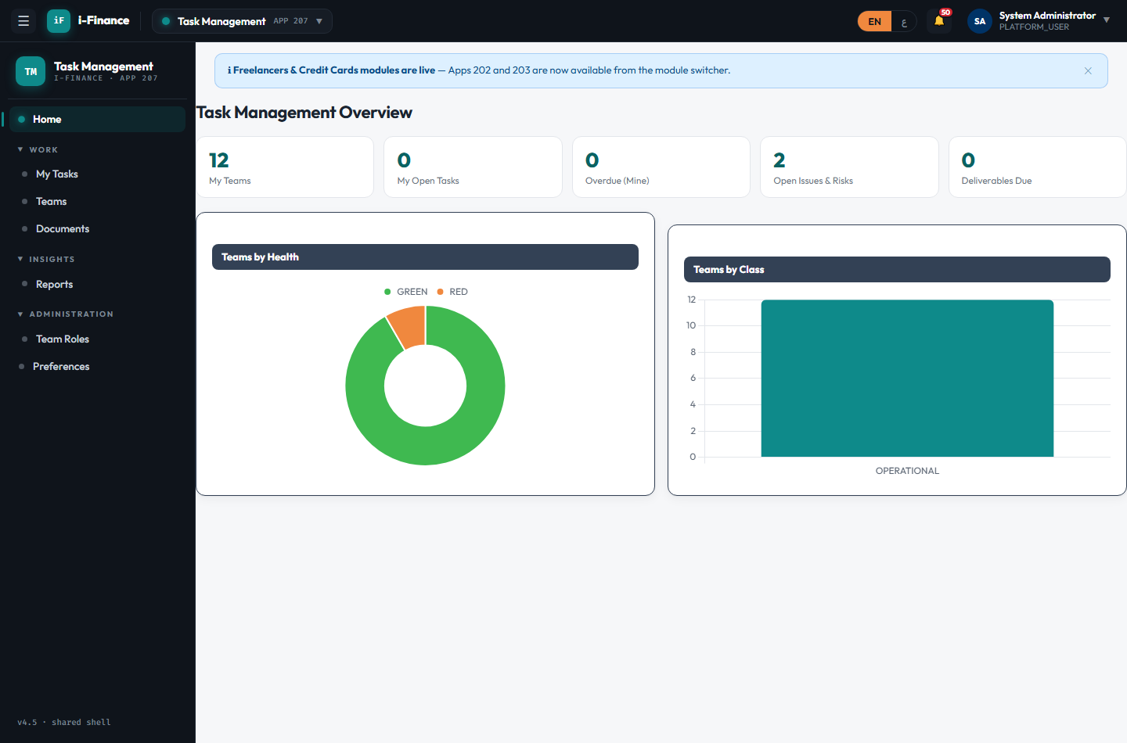
Evidence: TM-DSH-01.png

TM-DSH-02 — Teams by Health + Class
PASS · Charts · 4s
Expected: Both Chart.js charts render with data (no empty boxes)
Result: Teams-by-Health + Teams-by-Class charts rendered (2 canvases)

Evidence: TM-DSH-02.png

Teams

TM-TMS-01 — Team grid loads
PASS · List · 3s
Expected: Team cards show code, health RAG, type/class and member/task counts
Result: Teams grid shows 1 card(s); API total=12
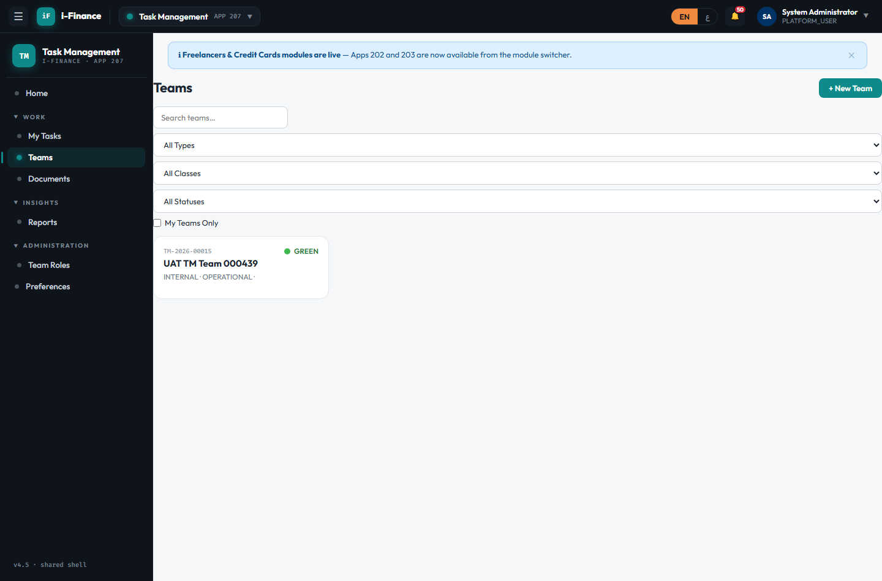
Evidence: TM-TMS-01.png

TM-TMS-02 — Type/class/status filters
PASS · Filter · 4s
Expected: Grid re-queries server-side and shows matching teams
Result: Type filter applied (INTERNAL); grid re-queried server-side
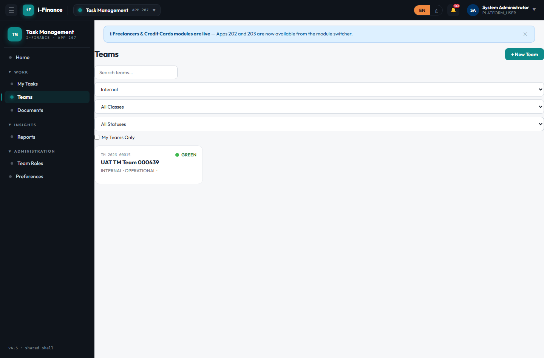
Evidence: TM-TMS-02.png

TM-TMS-03 — New team via platform modal
PASS · Create · 7s
Expected: Team created with a TM- code; creator auto-enrolled as Leader; appears in the grid
Result: Team "UAT TM Team 000815" created (TM-2026-00016) via the platform modal; leader auto-enrolled
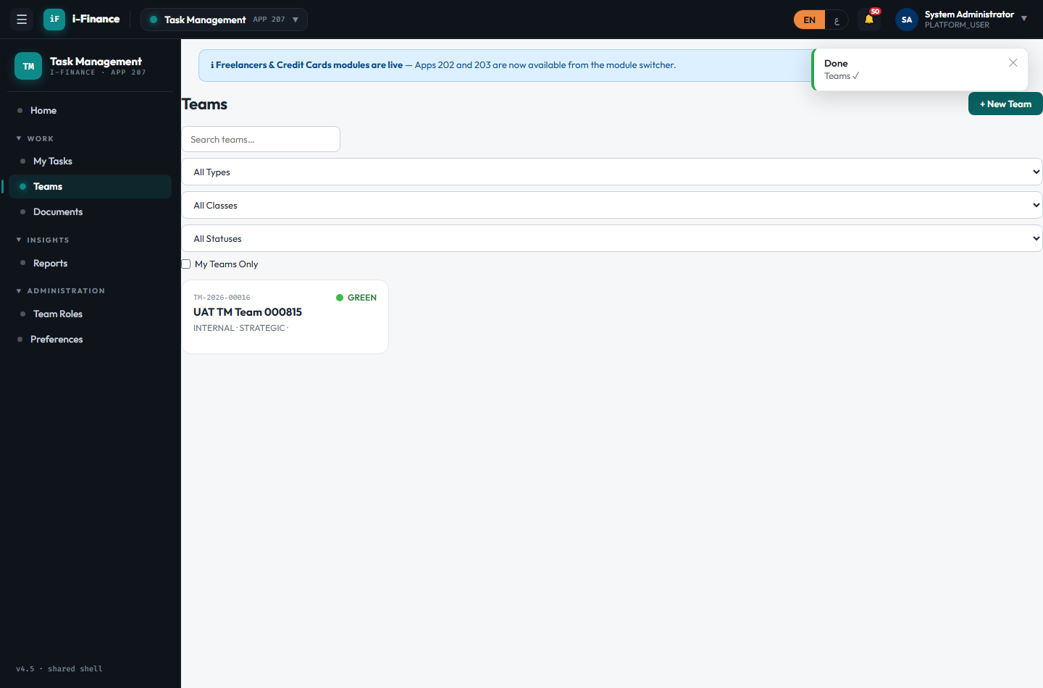
Evidence: TM-TMS-03.png

Team Detail

TM-DTL-01 — Full team definition grid
PASS · Overview · 3s
Expected: Overview shows ALL team fields in an aligned definition grid + KPI tiles + 9 tabs
Result: Overview shows full team definition grid (14 fields) + KPI tiles; 9 tabs present
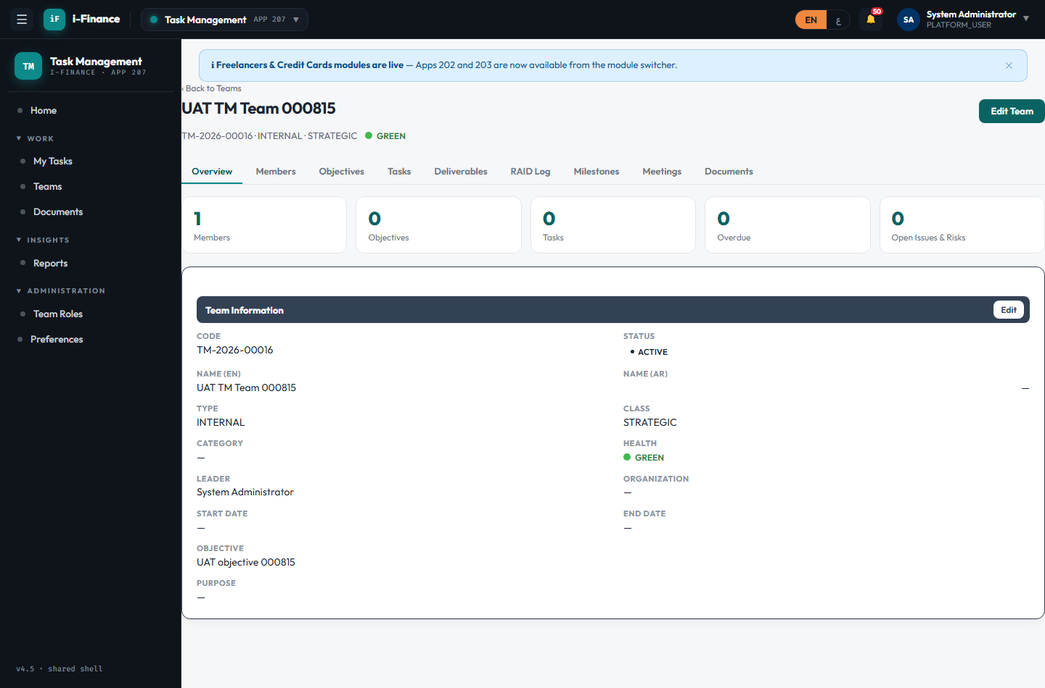
Evidence: TM-DTL-01.png

TM-DTL-02 — Edit Team modal persists
PASS · Edit team · 6s
Expected: Edit modal (top-right) saves via PUT; changes persist on reload
Result: Edit Team modal saved: objective updated + status=ON_HOLD (persisted via PUT)
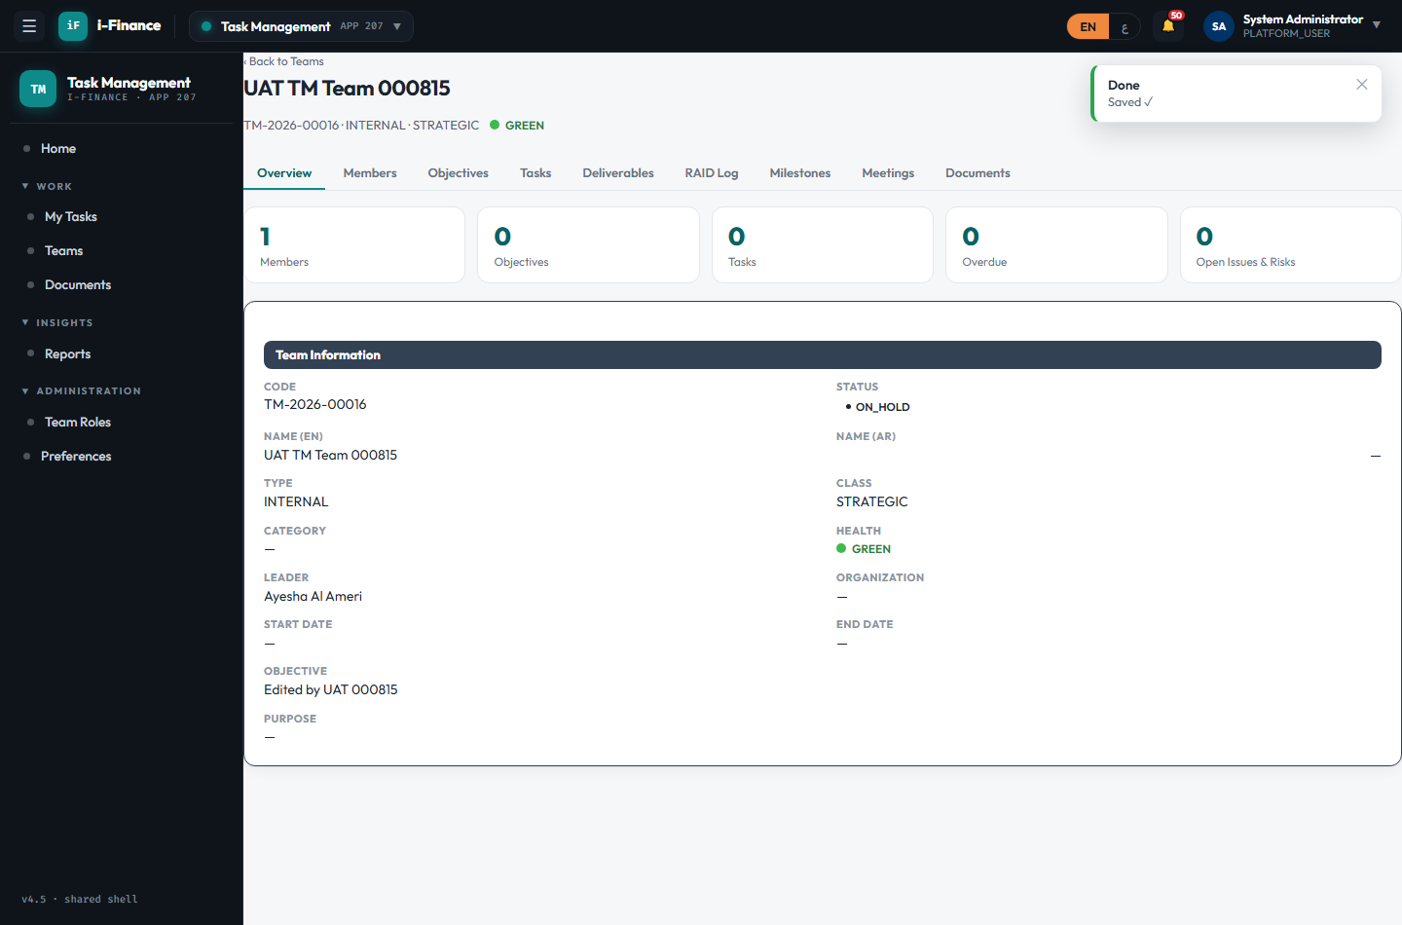
Evidence: TM-DTL-02.png

Members

TM-MBR-01 — Add from the user picker
PASS · Add member · 4s
Expected: Member added from DCT_USERS and listed with avatar + role
Result: Added Ayesha Al Ameri as MEMBER via the user picker; members table shows 2 rows
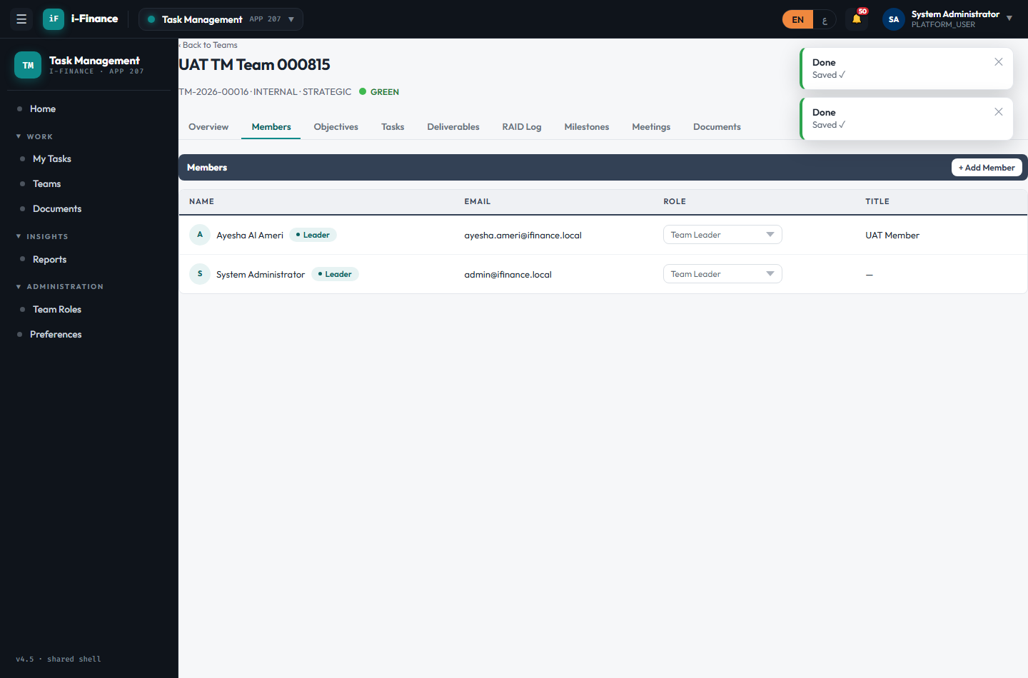
Evidence: TM-MBR-01.png

TM-MBR-02 — Inline role change
PASS · Change role · 3s
Expected: New team role persists
Result: Ayesha Al Ameri role changed MEMBER → COORDINATOR (persisted)

Evidence: TM-MBR-02.png

TM-MBR-03 — Remove from team
PASS · Remove member · 3s
Expected: Member removed and no longer listed
Result: Added then removed Hany; member no longer listed

Evidence: TM-MBR-03.png

Tasks

TM-TSK-01 — Add a task
PASS · Create · 3s
Expected: Task created and shown on the Kanban board
Result: Task created (HIGH, due +5d); appears on the Kanban TODO column
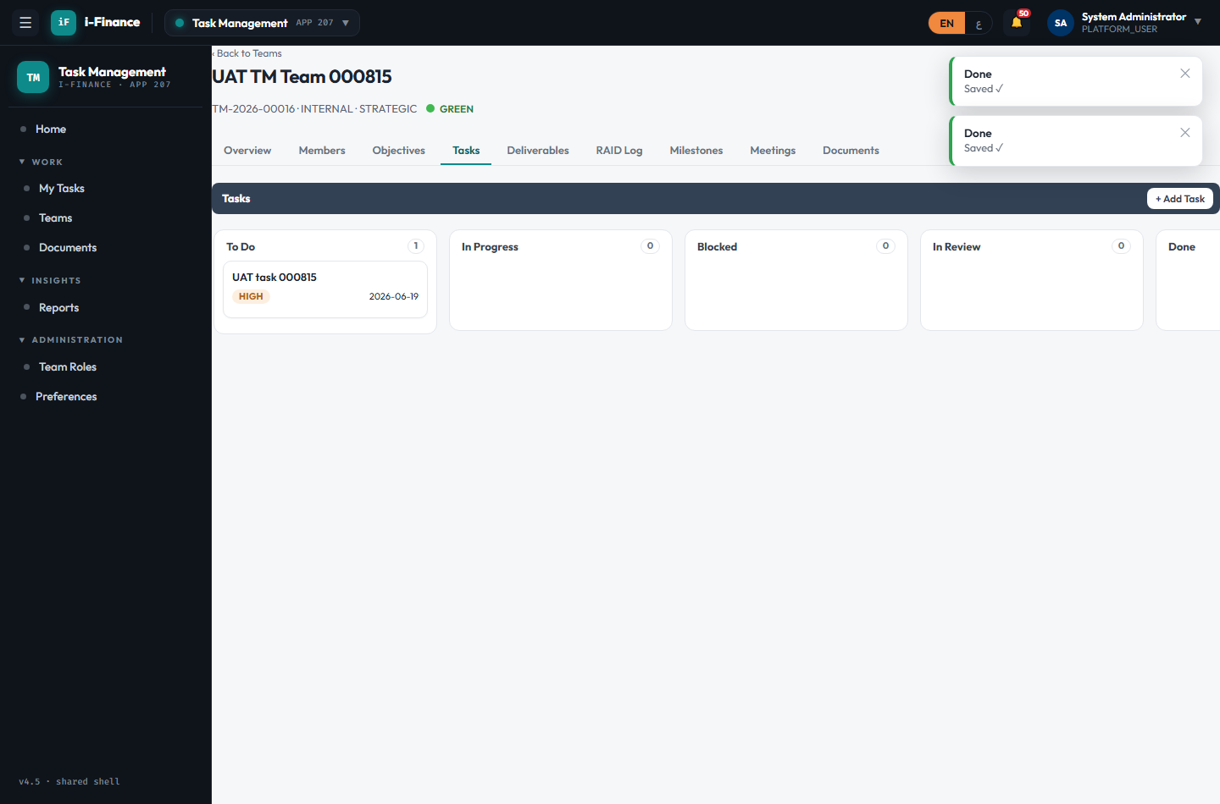
Evidence: TM-TSK-01.png

TM-TSK-02 — Move across columns
PASS · Kanban move · 3s
Expected: Status changes and status history is written
Result: Task moved TODO → IN_PROGRESS (status history written); reflected on the board
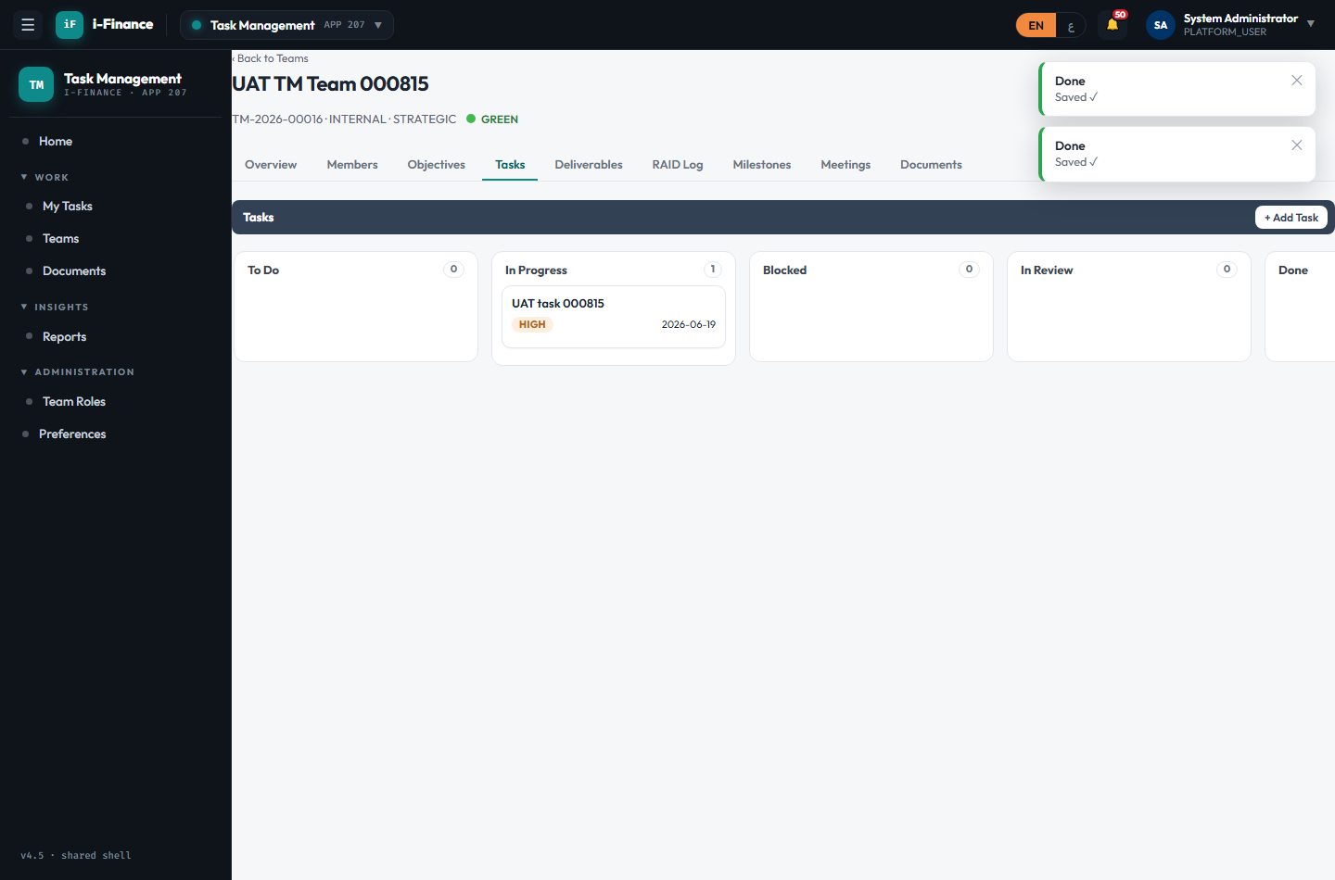
Evidence: TM-TSK-02.png

TM-TSK-03 — Assign a member
PASS · Assign · 5s
Expected: Assignee shown in the drawer with a primary badge
Result: Assigned Ayesha Al Ameri as primary; assignee shown in the task drawer
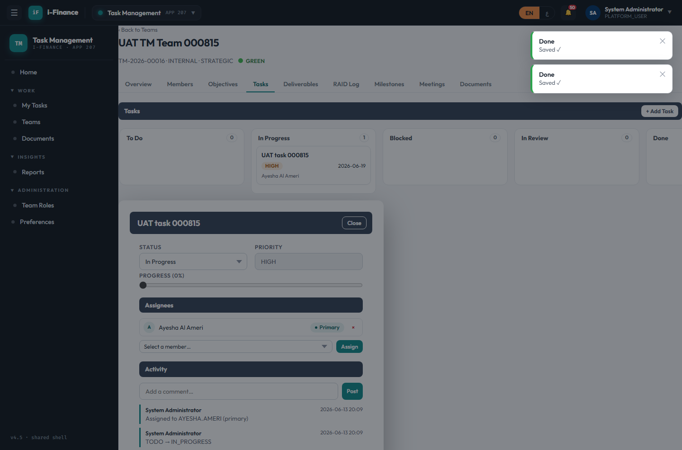
Evidence: TM-TSK-03.png

TM-TSK-04 — Reassignment is tracked
PASS · Reassign · 4s
Expected: Primary moves to the new member AND the activity feed logs the reassignment (audit trail)
Result: Primary reassigned to Hany; activity feed logged: "Primary assignee reassigned from AYESHA.AMERI to HANY"
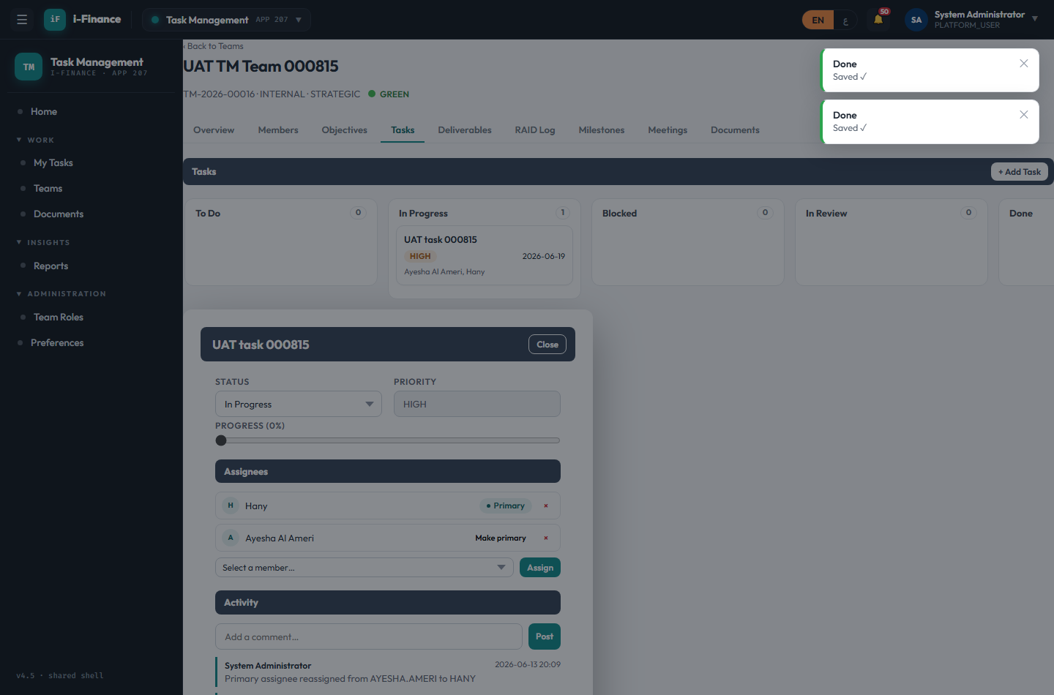
Evidence: TM-TSK-04.png

TM-TSK-05 — Activity feed comment
PASS · Comment · 0s
Expected: Comment appears in the activity feed
Result: Comment posted to the task activity feed and listed

Evidence: TM-TSK-05.png

Artifacts

TM-ART-01 — Add a deliverable
PASS · Deliverable · 3s
Expected: Deliverable created and listed
Result: Deliverable added and listed on the Deliverables tab
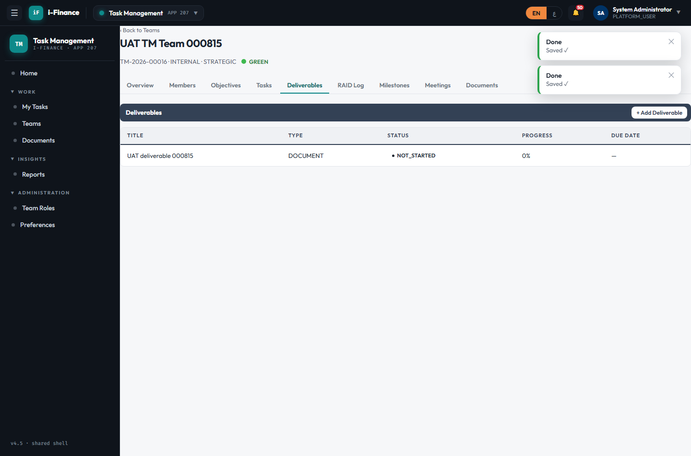
Evidence: TM-ART-01.png

TM-ART-02 — Add a RAID item
PASS · RAID · 3s
Expected: RAID item created and listed
Result: RAID risk (HIGH/OPEN) added and listed on the RAID Log tab
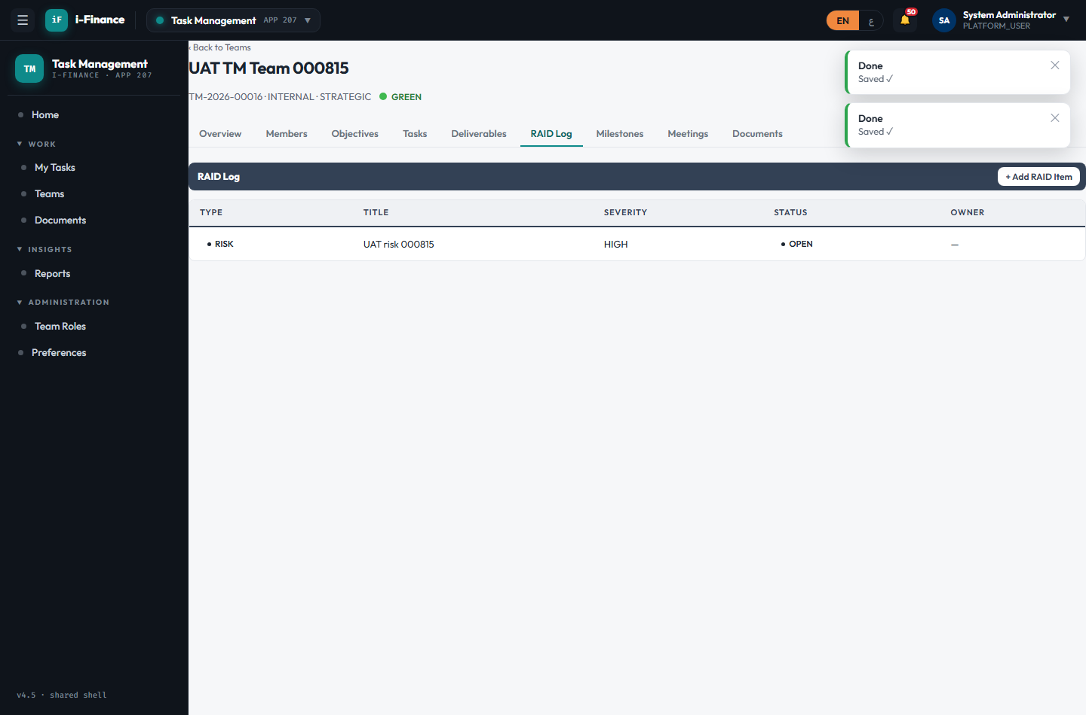
Evidence: TM-ART-02.png

TM-ART-03 — Add a milestone
PASS · Milestone · 3s
Expected: Milestone created and listed
Result: Milestone added (due +14d, PENDING) and listed on the Milestones tab
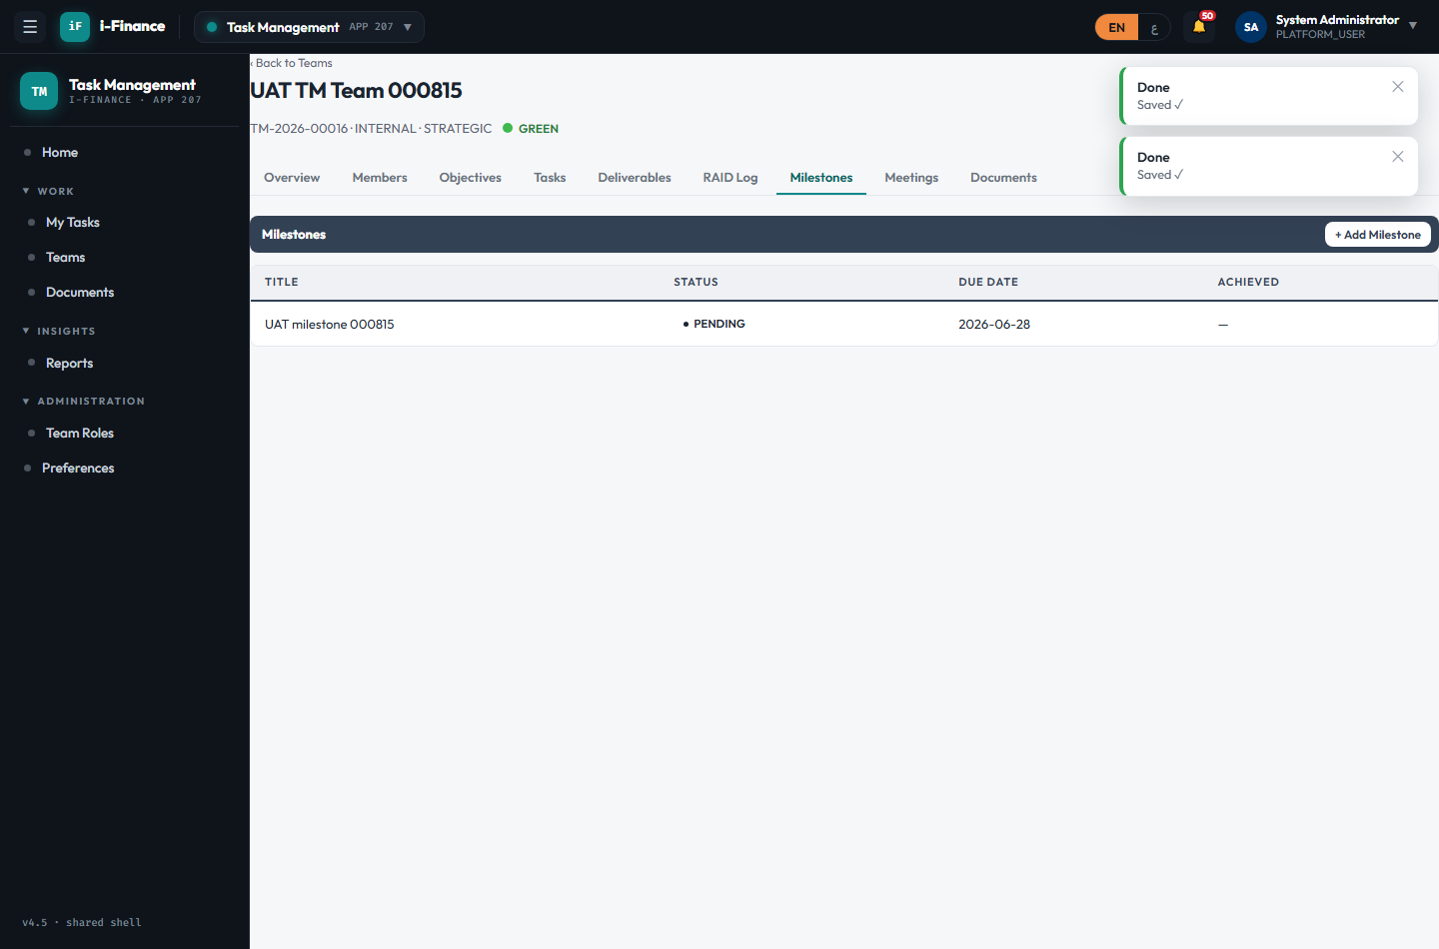
Evidence: TM-ART-03.png

TM-ART-04 — Add a meeting
PASS · Meeting · 3s
Expected: Meeting created and listed
Result: Meeting added (date +3d, Room 1) and listed on the Meetings tab
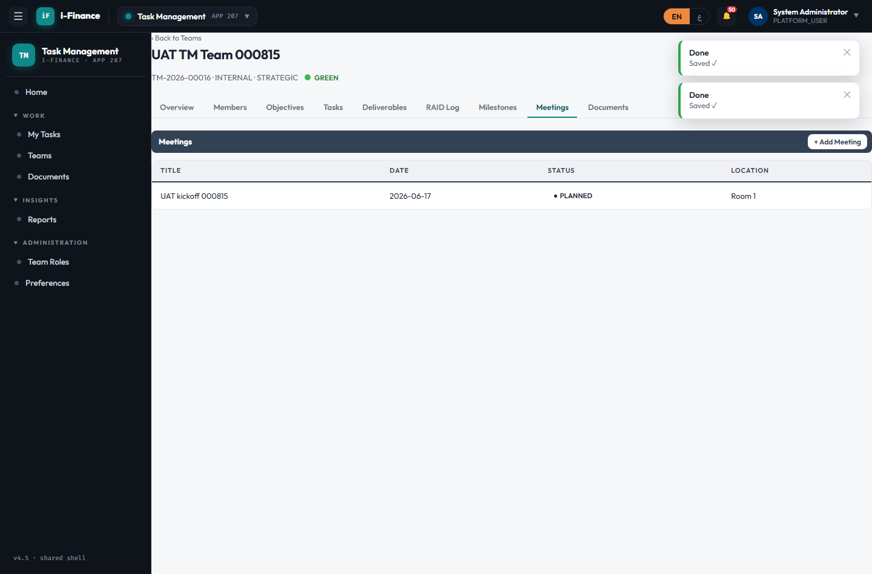
Evidence: TM-ART-04.png

TM-ART-05 — Add a team document
PASS · Document · 3s
Expected: Document stored in the unified store (source_module=TM) and listed
Result: Document added to the team (unified DCT_DOCUMENTS, source_module=TM) and listed
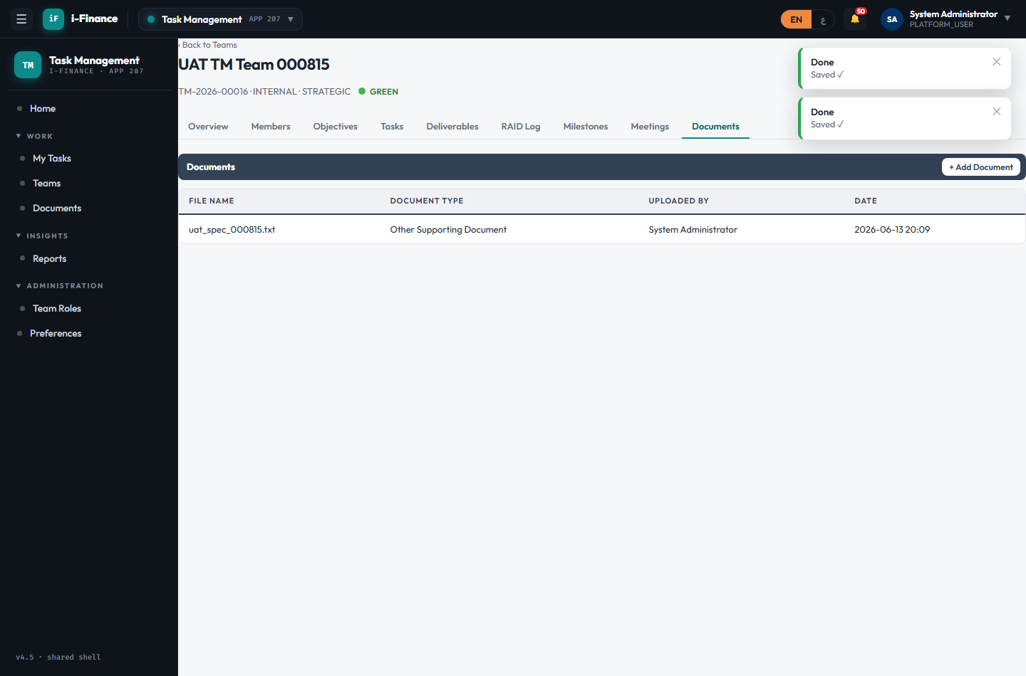
Evidence: TM-ART-05.png

Cross-cutting

TM-XCT-01 — Cross-team assigned tasks
PASS · My Tasks · 3s
Expected: Tasks assigned to me across all teams are listed
Result: My Tasks page loads ("My Tasks"); cross-team assigned tasks listed (API items=0)
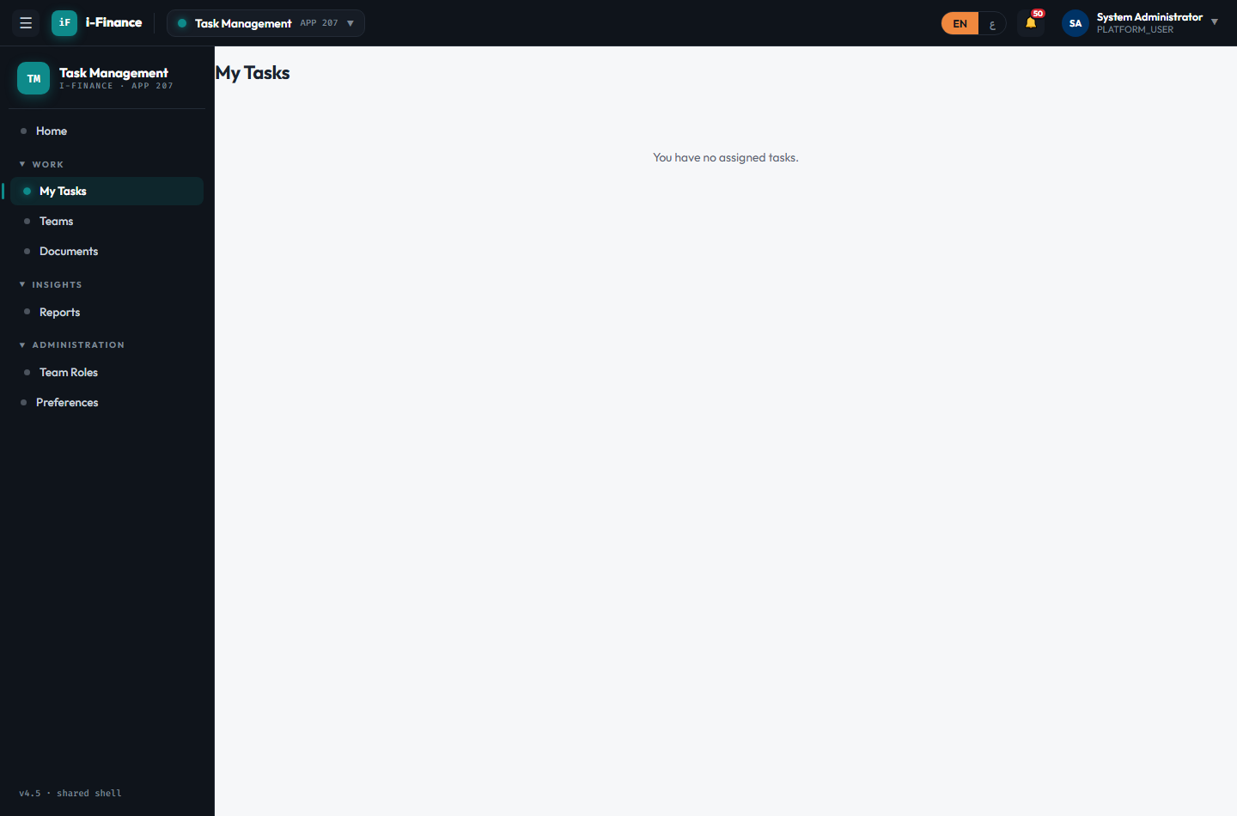
Evidence: TM-XCT-01.png

TM-XCT-02 — Management reports catalogue
PASS · Reports · 3s
Expected: The management report catalogue renders
Result: Management Reports page renders the report catalogue
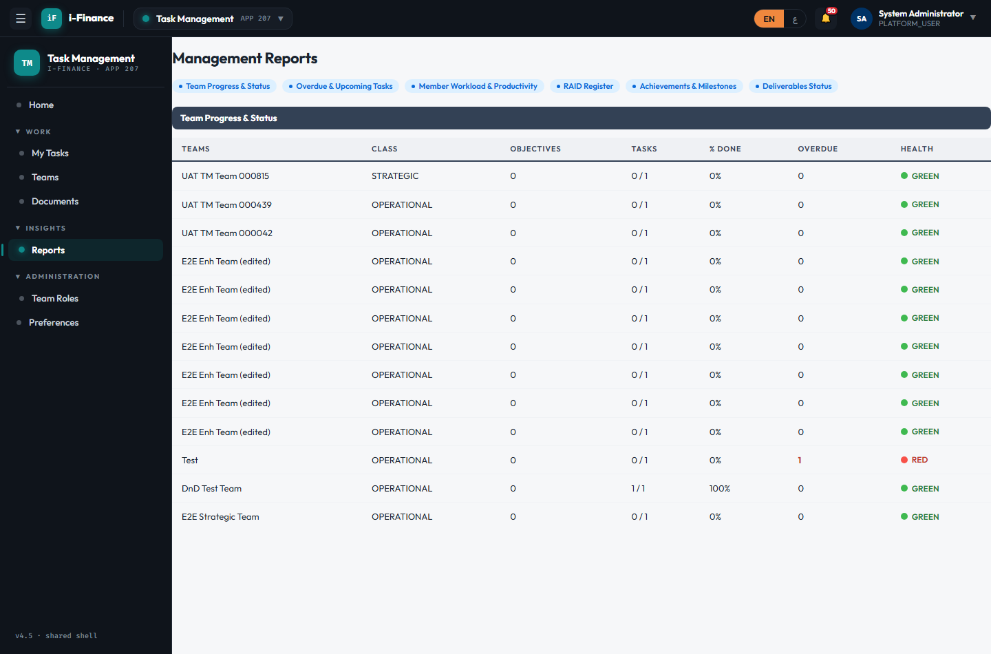
Evidence: TM-XCT-02.png

TM-XCT-03 — Reminder preferences
PASS · Preferences · 3s
Expected: Lead-days preference saves and persists
Result: Reminder preferences page loads; lead-days saved (5) and restored
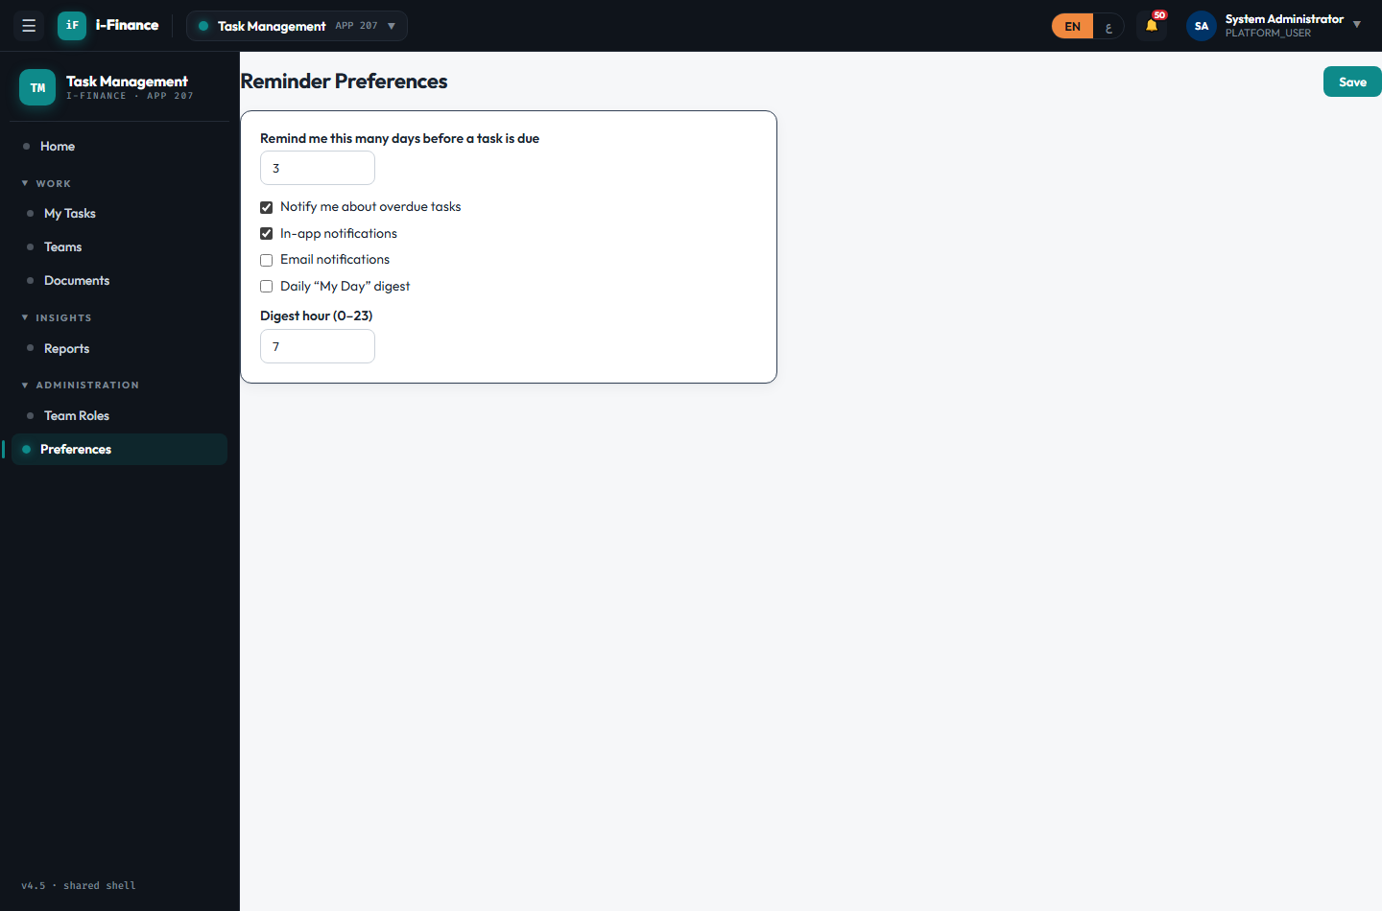
Evidence: TM-XCT-03.png

TM-XCT-04 — EN ↔ AR RTL
PASS · Language · 6s
Expected: Shell flips RTL with Arabic labels; Latin digits retained
Result: EN→AR flips the shell to RTL with Arabic labels; numbers stay Latin digits; restored to EN
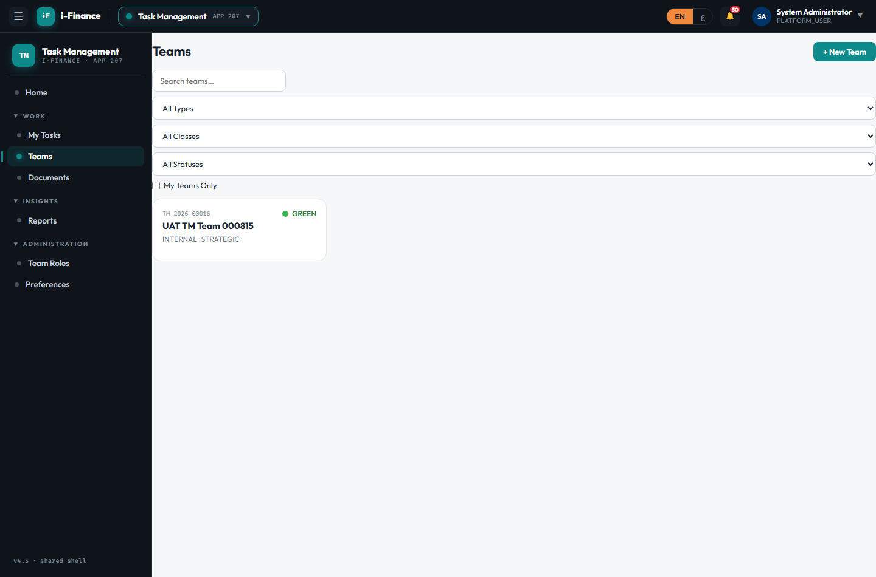
Evidence: TM-XCT-04.png

